A


PROJECT REPORT
ON
E-BLOOD BANK”

SUBMITTED
TO
ROURKELA INSTITUTE OF MANAGEMENT STUDIES
(As a partial fulfillment of the requirement for the award of degree)
FOR
MASTER OF COMPUTER APPLICATION
SUBMITED
BY
VARSHA RANI
MCA 5th SEMESTER
REGD NO: 1605260012
ROURKELA INSTITUTE OF MANAGEMENT STUDIES
(Affiliated to Biju Patnaik University of Technology)

ACKNOWLEDGEMENT

I would like to express my gratitude to Mr. Praveen Kumar Rout, “Lakshaya Institute Of Technology” for his guidance and support during the project work.

I acknowledge the help and co-operation received from all the staff members of “Lakshaya Institute Of Technology”, in making this project.

I am deeply indebted to Rourkela Institute of Management Studies, Chhend , Rourkela for providing me an opportunity to undertake a project work entitled E-Blood Bank” .I am grateful to my project guide Mr. Praveen Kumar Rout without his guidance it would not have been possible on my part to complete the project.

I consider myself fortunate that I have successfully completed this project; I acknowledge my sincere gratitude to all those works and ideas that had helped me in writing this project.

Date:

Himanshu Sekhar Sahoo
University roll. No.: 1605260012

CERTIFICATE

This is to certify that the report entitled E-Blood Bank developed satisfactory at the institute by Varsha Rani , bearing university roll no:-1605260012 towards the partial fulfillment of Master in Computer Application, session(2016-2019) under the post graduate course, Rourkela Institute of Management Studies(affiliated to BPUT,Odisha).

During the period of the presentation work he has found to be sincere and his conduct remained satisfactory.

Place:
Date:

Signature of H.O.D Signature of External

CONTENTS
1. Introduction
2. System Analysis

- Feasibility Study
    - Technical Feasibility
    - Operational Feasibility
    - Economical Feasibility

- System Study

- Existing System
- Proposed System

3. System Requirements

- Working Environment
- Hardware Configuration
- Software Configuration

4. System Design
- E-R diagram
- Data Flow Diagrams
- UML
5.Outputscreen
6. Conclusion
7. Bibliography

INTRODUCTION
Project Overview

The Blood Donation Agent is to create an e-Information about the donor and organization that are related to donating the blood. Through this application any person who is interested in donating the blood can register himself in the same way if any organization wants to register itself with this site that can also register. Moreover if any general consumer wants to make request blood online he can also take the help of this site. Admin is the main authority who can do addition, deletion, and modification if required.

Project Description

This project is aimed to developing an online Blood Donation Information. The entire project has been developed keeping in view of the client server computing technology, in mind.
The Blood Donation Agent is to create an e-Information about the donor and organization that are related to donating the blood. Through this application any person who is interested in donating the blood can register himself in the same way if any organization wants to register itself with this site that can also register. Moreover if any general consumer wants to make request blood online he can also take the help of this site.
Admin is the main authority who can do addition, deletion, and modification if required.
The project has been planned to be having the view of client server architecture, with centralized storage of the database. The application for the storage of the data has been planned. Using the constructs of Apache Server and all the user interfaces have been designed using the Php technologies.

SYSTEM ANALYSIS
Feasibility Study:
The feasibility study is performed to determine whether the proposed system is viable considering the Technical, Operational and Economical factors. After going through feasibility study we can have a clear-cut view of the systems benefits and drawbacks.

Technical Feasibility:
The proposed system is developed using HTML as front-end tool and My Sql as the back end. The proposed system needs a Personal Web Server to serve the requests submitted by the users. The Web browser is used to view the web page that is available within the Windows operating system itself. The proposed system will run under Win9x, NT, and win2000 environment. As Windows is very user friendly and GUI OS it is very easy to use. All the required hardware and software are readily available in the market. Hence the system is technically feasible.

Operational Feasibility:
The proposed system is operationally feasible because of the following reasons:

- The customer is benefited more as most of his time is saved. The customer is serviced at his place of work.
- The cost of the proposed system is almost negligible when compared to the benefits gained.

Economical Feasibility:
As the necessary hardware and software are available in the market at a low cost, the initial investment is the only cost incurred and does not need any further enhancements. Hence it is economically feasible.
The system is feasible in all respects and hence it encourages taking up the system design.

SYSTEM STUDY

Problem Definition
2.1 Existing System
- Cannot Upload and Download the latest updates.
- No use of Web Services and Remoting..
- Less Security.
- No proper coordination between different Applications and Users.
- Fewer Users  Friendly
2.2. Proposed System
To debug the existing system, remove procedures those cause data redundancy, make navigational sequence proper. To provide information about audits on different level and also to reflect the current work status depending on organization/auditor or date. To build strong password mechanism.

BENEFITS:
The project is identified by the merits of the system offered to the user. The merits of this project are as follows: -
- Its a web-enabled project.
- This project offers user to enter the data through simple and interactive forms. This is very helpful for the client to enter the desired information through so much simplicity.
- The user is mainly more concerned about the validity of the data, whatever he is entering. There are checks on every stages of any new creation, data entry or updation so that the user cannot enter the invalid data, which can create problems at later date.
- Sometimes the user finds in the later stages of using project that he needs to update some of the information that he entered earlier. There are options for him by which he can update the records. Moreover there is restriction for his that he cannot change the primary data field. This keeps the validity of the data to longer extent.
- User is provided the option of monitoring the records he entered earlier. He can see the desired records with the variety of options provided by him.
- From every part of the project the user is provided with the links through framing so that he can go from one option of the project to other as per the requirement. This is bound to be simple and very friendly as per the user is concerned. That is, we can sat that the project is user friendly which is one of the primary concerns of any good project.
- Data storage and retrieval will become faster and easier to maintain because data is stored in a systematic manner and in a single database.
- Decision making process would be greatly enhanced because of faster processing of information since data collection from information available on computer takes much less time then manual system.
- Allocating of sample results becomes much faster because at a time the user can see the records of last years.
- Easier and faster data transfer through latest technology associated with the computer and communication.
- Through these features it will increase the efficiency, accuracy and transparency,

LIMITATIONS:
- The size of the database increases day-by-day, increasing the load on the database back up and data maintenance activity.
- Training for simple computer operations is necessary for the users working on the system.

SOFTWARE REQUIREMENTS

Hardware Configuration:

Processor : P III 700 MHz.
RAM : 64 MB RAM
Hard Disk Drive : 20 GB HDD
Keyboard : 104 keys
Mouse : Logitech Mouse
Monitor : 15 digital color monitor
Display Type : VGA

Software Configuration:
Operating System : Windows 7
Web server : Apachhe web server
Web Browser : Internet Explorer5.0
Designing Tool : sublime text editor
Server Side Scripting : PHP
Client Side Scripting : java script,html
Backend : My sql

The modules involved are:
- Administration:
In this module the Administrator has the privileges to add all the Blood Groups, Blood Type, Type, Country, State, City, and Location. He can search all the info about the Organization, Donor.
User Account:
- AdminID
- Username
- Password
- UpdationDate
- Address
- Email
- Mobile
- SecurityQuestion
- Answer
Functionality

    - Association User Account with UserRole.
    - Association User Account with Organisation.
    - Association User Account with personal Details.
    - Association User Account with BloodDonation Details.
Alerts:
- All fields are mandatory
- Select user role
- Select role id
- Select role name

BloodStore:
  - SerialNo
  - BloodGroup
  - Totalnoofblood
Functionality:
- Association Blood group with Personal details.
Alerts:
- Select Serialno

Users:

- UserID
- Passsword
- FirstName
- LastName
- Email
- DOB
- Gender
- BloodType
- Address
- City
- MobileNo
Functionality:
- Association personal detaials with preferd location Day Time Details.

Alerts:
- Select user account id
- Select Email id
- Select date of birth

Employee Detail:
- EmpId
- FirstName
- MiddleName
- LastName
- UserName
- Password
- BirthDay
- Designation
- MobileNumber
Functionality:
- Association Employee Details type with user Accounts.
Alerts:
- Select Emp Id
- Select email id

Donor:
Donor is that person who is interested in donating their blood so they can register themselves through this website. If any requirement comes then they will be contacted and they can donate their blood. Along with it they can search for the various organization locations wise and can also make request for blood if needed

Donation Frequencies:
- ID
- Password
- Fname
- Lname
- Sex
- Blood_type
- Diseases
- Birthday
- Address
- City
- Donation_date
- Temp
- Bp
- Weight
- Mobile
Functionality:
- Association Donor Frequencies with Blood donation preferences.

Alerts:
- Select Id
SYSTEM DESIGN
ER DIAGRAM

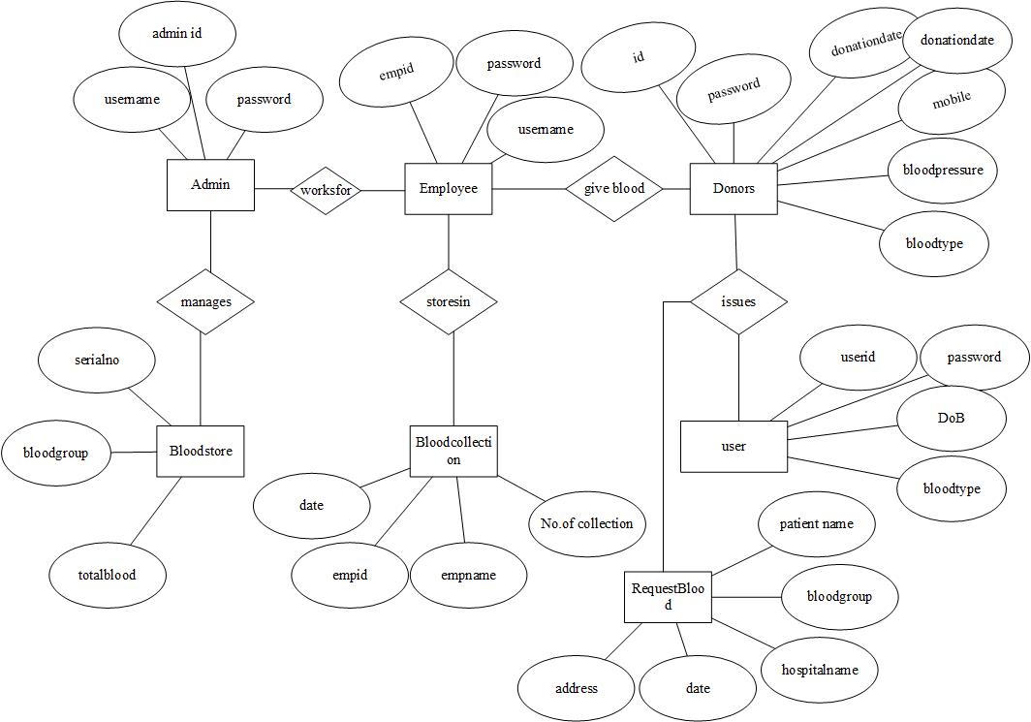

Data Flow Diagrams (DFD)
A data flow diagram is graphical tool used to describe and analyze movement of data through a system. These are the central tool and the basis from which the other components are developed. The transformation of data from input to output, through processed, may be described logically and independently of physical components associated with the system. These are known as the logical data flow diagrams.
The physical data flow diagrams show the actual implements and movement of data between people, departments and workstations. A full description of a system actually consists of a set of data flow diagrams. Using two familiar notations Yourdon, Gane and Sarson notation develops the data flow diagrams. Each component in a DFD is labeled with a descriptive name. Process is further identified with a number that will be used for identification purpose.
The development of DFDS is done in several levels. Each process in lower level diagrams can be broken down into a more detailed DFD in the next level. The lop-level diagram is often called context diagram. It consists a single process bit, which plays vital role in studying the current system. The process in the context level diagram is exploded into other process at the first level DFD.
The idea behind the explosion of a process into more process is that understanding at one level of detail is exploded into greater detail at the next level. This is done until further explosion is necessary and an adequate amount of detail is described for analyst to understand the process.
Larry Constantine first developed the DFD as a way of expressing system requirements in a graphical from, this lead to the modular design.
A DFD is also known as a bubble Chart has the purpose of clarifying system requirements and identifying major transformations that will become programs in system design. So it is the starting point of the design to the lowest level of detail. A DFD consists of a series of bubbles joined by data flows in the system.

Context Diagram
Admin

DataBase

Employee

Blood Donation Agent

Donor

User

1st Level DFDs
Level 1 DFD: For Admin Module

Admin
login

Login data

View of value Abilities details

Value Abilities Table

Level 1 DFD: For Users Module

Users
Login

updating and
editing

Value Abilities Table

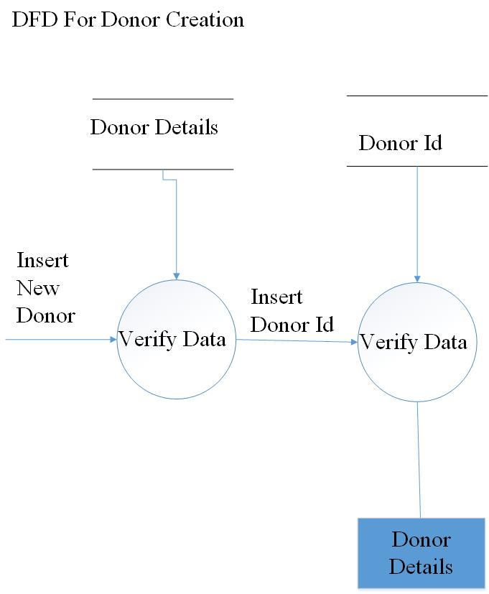

UML DIAGRAMS

Use Case Diagram:
  - The unified modeling language allows the software engineer to express an analysis model using the modeling notation that is governed by a set of syntactic semantic and pragmatic rules.
  - A UML system is represented using five different views that describe the system from distinctly different perspective. Each view is defined by a set of diagram, which is as follows.
  - User Model View
    - This view represents the system from the users perspective.
    - The analysis representation describes a usage scenario from the end-users perspective.
Structural model view
- In this model the data and functionality are arrived from inside the system.
- This model view models the static structures.
Behavioral model view
It represents the dynamic of behavioral as parts of the system, depicting the interactions of collection between various structural elements described in the user model and structural model view.
Implementation Model View
In this the structural and behavioral as parts of the system are represented as they are to be built.
Environmental Model View
In this the structural and behavioral aspects of the environment in which the system is to be implemented are represented.
UML is specifically constructed through two different domains they are
- UML Analysis modeling, which focuses on the user model and structural model views of the system.
- UML design modeling, which focuses on the behavioral modeling, implementation modeling and environmental model views.

Use case Diagrams represent the functionality of the system from a users point of view. Use cases are used during requirements elicitation and analysis to represent the functionality of the system. Use cases focus on the behavior of the system from external point of view.
Actors are external entities that interact with the system. Examples of actors include users like administrator, customer etc., or another system like central database.
Use case Model
SYSTEM NAME

Use case 1

Use case 2

Use case n

Actor
Actor

Use Cases of Blood Donation Agent Interface
Use case For Admin Module

E-Blood Donation


Home Page


Services

Blood List

Registration

Login

Request Blood

Search

Contact us

About US

Admin

Use case For Donor Module

E-Blood Donation

Home Page

Profile

Registration

Change Password

Donor

Use case name | Login
Participating actors | Admin, Donor
Flow of events | The Actor will give the user name and password to the system. The system will verify the authentication.
Entry Condition | The actor will enter the system by using username and password
Exit condition | If un authenticated should be exited
Quality Requirements | Password must satisfy the complexity requirements.

Use case name | Admin Registration
Participating actors | Admin
Flow of events | The Admin will submit all the details and place in the application.
Entry Condition | Must satisfy all the norms given by the Blood Donation Agent interface site.
Exit condition | Successful or Un successful completion of creation of account.
Quality Requirements | All fields are mandatory.

Use case name | Donor Registration
Participating actors | Donor
Flow of events | The Donor must enter all his personal details.
Entry Condition | View Home page
Exit condition | Registered Donor should be successfully logged out. Error Message should be displayed on Un successful creation.
Quality Requirements | Best Error Handling techniques. Check on Mandatory fields.

SEQUENCE DIAGRAMS
Sequence Diagrams Represent the objects participating the interaction horizontally and time vertically.
Sequence Diagram for Admin
Admin
: Login
: Create A/C BanAccount
: Log Out
Use url
Press login button
Press Create Account
Time
Sequence Diagram for Donor
Donor
: Login
: Accounts
DB
Press login button ()

Get login page ()

Validate forms ()
Press create accounts button ()

Database Tables
1.Entities

- Admin
- Users
- Employees
- Donors
- Bloodstore
- Blood Collection
- Request Blood

2.Entities with Attributes
- Admin
- Admin Id
- Username
- Password
- Updationdate
- Address
- Email
- Mobile
- Securityquestion
- Answer
- Users
  - Userid
  - Password
  - Firstname
  - Lastname
  - Email
  - Dob
  - Gender
  - BloodType
  - Address
  - City
  - Mobile No.
- Employees
- Empid
- Firstname
- Lastname
- Username
- Password
- Birthday
- Designation
- Mobile no.
- Donors
- Id
- Password
- Firstname
- Lastname
- Sex
- Bloodtype
- Birthday
- Diseases
- Address
- City
- Donationdate
- Temperature
- Bloodpressure
- Weight
- Mobile

- Blood Store
- Serial No
- Blood Group
- Total No Of Blood
- Blood Collection
- EmpID
- EmpName
- Date
- No_of_Blood Collection
- Request Blood
- Patient Name
- Hospital Name
- Blood Group
- Date
- Address
Database Connectivity

EMPLOYEE

<?php
session_start();
if(isset($_POST['login']))
{
$empid=$_POST['empid'];
$password=$_POST['password'];
$sql="select * from employees where empid='".$empid."' and password='".$password."'";
include 'db.php';
$i=mysqli_query($con,$sql);
if($arr=mysqli_fetch_array($i))
{
if($arr['status']==0)
{
$_SESSION['empid']=$empid;
header('location:employeeloginsuccess.php');
}
else
{
$msg="Account is Invalid";
}
}
else
{
$msg="Invalid empid or password";
}
}
?>
<!DOCTYPE html>
<html>
<head>
<meta charset="utf-8">
<title>Login Form</title>
<link rel="stylesheet" type="text/css" href="style.css">
</head>
<body>
<div class="loginbox">
<img src="images/users.jpg" class="user">
<h2>Login Here</h2>
<form method="post">
<P>empid</P>
<input type="text" name="empid" placeholder="Enter empid"></input>
<p>Password</p>
<input type="password" name="password"placeholder="Enter Password"></input>
<input type="submit" name="login" value="Sign In"></input>
<center>DONT HAVE ANY ACCOUNt?</center>
<br/><center><a href="register.php">SIGN UP</a></center>
</form>
</div>
</body>
</html>

SCREENSHOT

HOMEPAGE

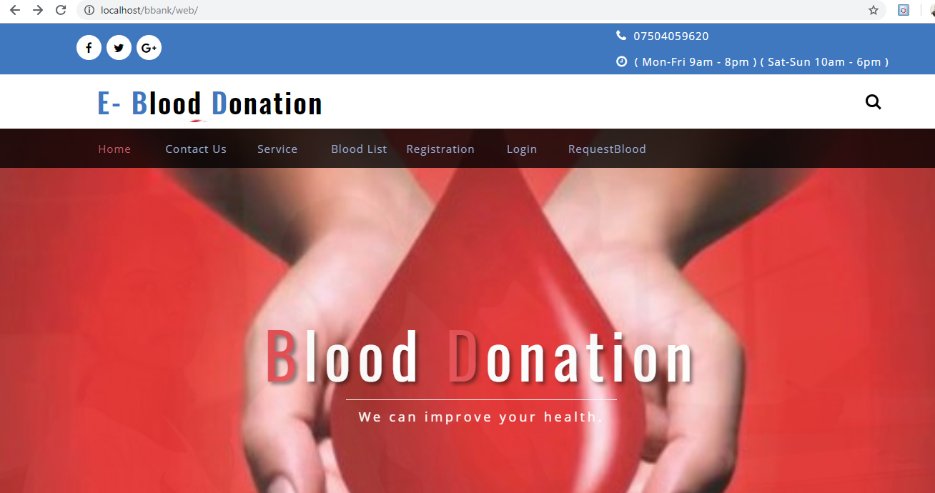

REGISTRATION
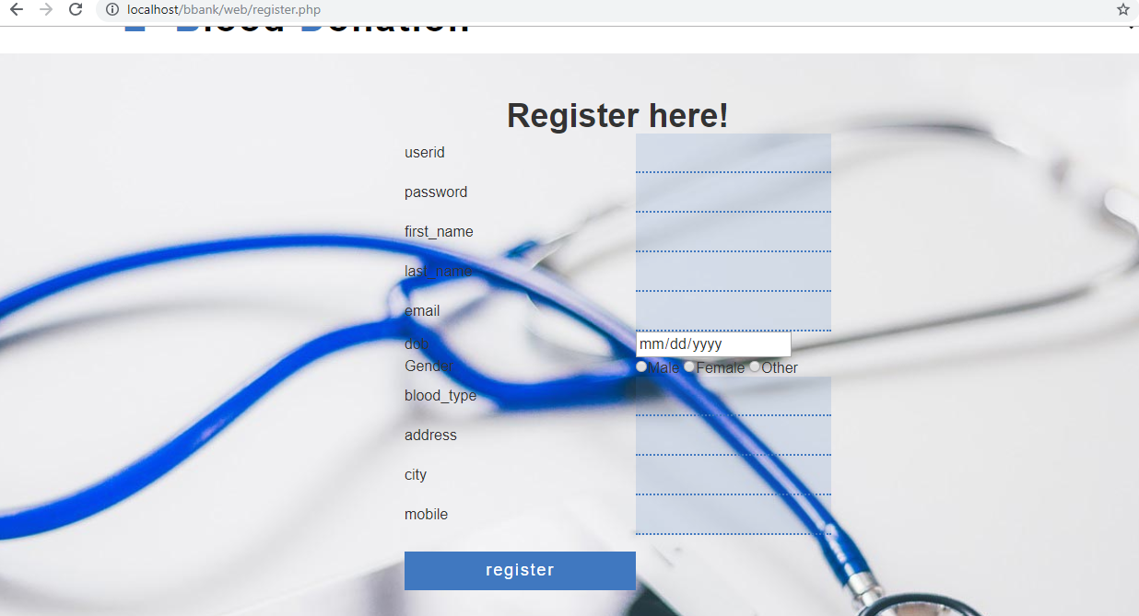

LOGIN PAGE
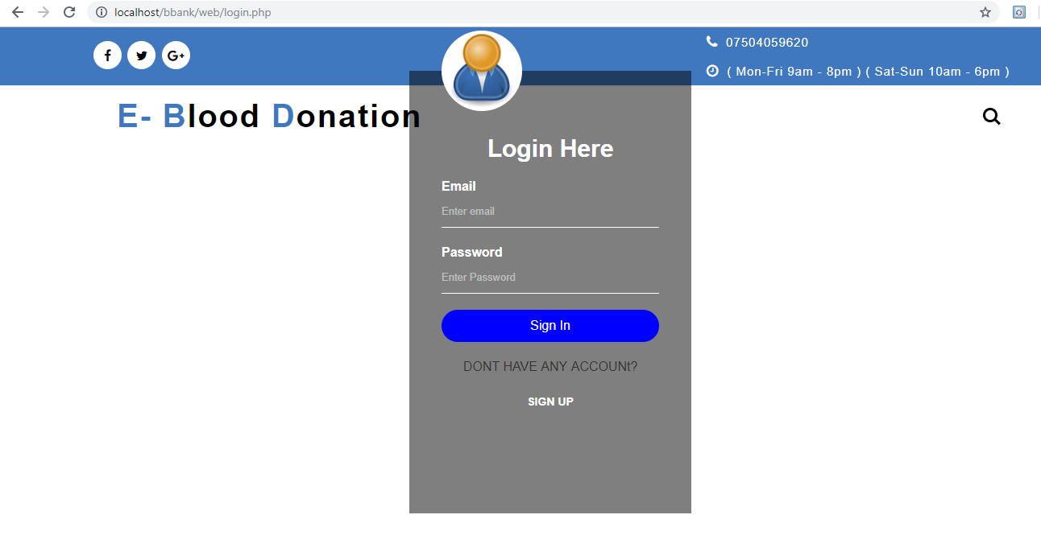
BLOODLIST
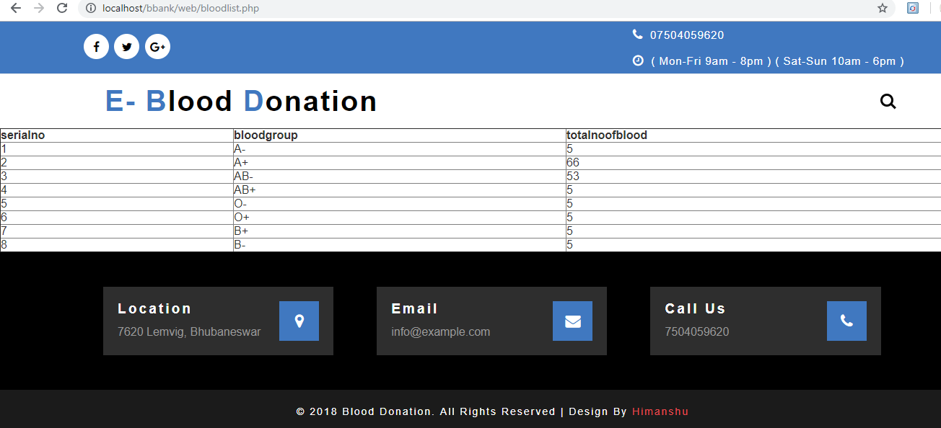
CONCLUSION
It has been a great pleasure for me to work on this exciting and challenging project. This project proved good for me as it provided practical knowledge of not only programming in PHP,SQL Server, It also provides knowledge about the latest technology used in developing web enabled application and client server technology that will be great demand in future. This will provide better opportunities and guidance in future in developing projects independently.

BIBLOGRAPHY
- www.google.com

